The All Party Parliamentary Light Rail Group (AAALRG)
House of Commons
London

2nd October 2009

Dear Sirs

APPLRG INQUIRY

My name is Roger Harrison. I work for Keolis (UK) Ltd as Projects Director LRT. I am also a steering group member of the Light Rapid Transit Forum and a Director of UK Tram. My contact details are:

e-mail:rharrison@keolis.com

Mobile 07776 201 579

Section (b) of the Inquiry sets out:

To compare the UK experience with progress on light rail schemes on the continent
i) What has been the experience in delivering light rail schemes on the continent?
ii) What are the common issues and barriers, and how have these been addressed?
iii) What are the key lessons from Europe in progressing light rail?

Keolis is one of the major tram operators in France (Lyon, Lille, Bordeaux and Le Mans) and is also involved in development of tram schemes in Angers, Brest, Dijon, Tours and Besançon. Keolis is also a major international tram operator and from 1 December, 2009, will be operator of the world’s largest tram system in Melbourne, Australia. Keolis will also be the operator of new tramway projects in Bergen (Norway) and Algiers (Algeria). I feel that the Inquiry might benefit from a French perspective and experience of one of the most recent tramways to be built, in Le Mans. Keolis is also the Preferred Operator for the Merseytram Project in Liverpool and has tendered for a tramway franchise in Manchester and the Dublin Metro North LRT PPP tender.

Yours faithfully
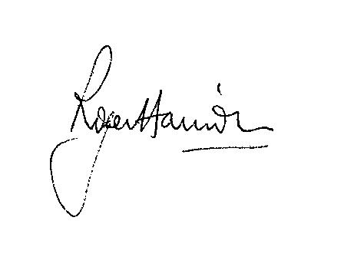

Roger Harrison
BSc, C Eng, MIMechE, CDipFA, DIA

